Bipin Tripathi Kumaon Institute of Technology, Dwarahat

BACHELOR OF TECHNOLOGY
(MECHANICAL ENGINEERING)


Project Title: Computer Aided Design of Robotic Gripper
Session: 2022-23

Submitted to: Dr. Dev Prakash Satsangi
(Assistant Professor Mechanical Department)

Submitted by: Bhaskar Bhatt
Roll number: 210180104009.
2nd year 4th semester

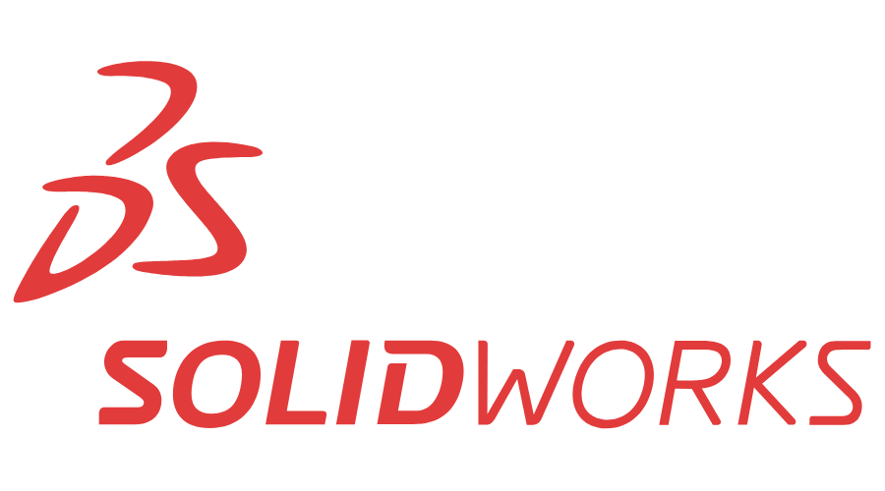

About Software:
SOLIDWORKS is used by millions of designers and engineers at hundreds of thousands of companies. It’s one of the most popular design and engineering software on the market. Known for its range of features and high functionality, SOLIDWORKS is used across multiple professions and industries around the world.
SOLIDWORKS uses parametric design, which is why it’s such an effective tool for designers and engineers. This means that the designer can see how changes will affect its neighbouring components, or even the overall solution. For example, if the size of a single component is increased, this would affect the joint or hole it’s attached to. This allows designers to spot and correct issues quickly and easily.

SOLIDWORKS Features
- Simple but sophisticated 3D CAD design
- Use templates and the CAD library for improved efficiency.
- Automation and design reuse to speed up the process.
- Cost estimation tools allow you to keep track in real-time.
- Ensure potential risks are caught early with interference check.
- Quickly produce 2D drawings for production.
- Easily create animations and photorealistic renderings.
As mentioned above, SOLIDWORKS is a parametric CAD program, which is easy to use and highly efficient. That makes it a favourite for both students and experienced designers.
As with most software, familiarizing yourself with the buttons, names, and User Interface can take some time. However, there are some great, unique functions to aid new users in this process and optimize for the best user experience. And there are many helpful tutorials available that offer great insight and an introduction to the design process.

Robot Grippers
A robot gripper is a device that enables industrial robots to pick up and hold objects. They are the tools you need to make your automated robot arm system customizable to your industry. If your workplace solution requires robotic manipulators and adaptive grippers for automated tasks, selecting the correct gripper is essential. From two-fingered grippers to suction cups, the correct end-of-arm robotic gripper is needed to interact with your products or workpieces.
RS provides a wide range of robot grippers designed for use with a variety of robot arms, with a selection of achievable gripping forces to suit your application. Whether you require robotics solutions for automated high-speed pick-and-place, or collaborative robots for precision welding and gluing, there is a robot gripper and end effector to suit.

Robot gripper Types:
Robot grippers come in various actuation types including Electric, Pneumatic and Vacuum.
Electric Robot grippers – This type of gripper design does not have the same level of gripping power as a hydraulic pneumatic, suction, or vacuum gripper. Electric grippers are best suited to applications pick-and-place light picking force and speed is required.
Pneumatic grippers - This type of gripper design uses compressed air and a series of pistons to operate the jaws or fingers.
Vacuum grippers – This type of gripper design uses atmospheric pressure and vacuum to move and lift objects. Vacuum grippers are very powerful and are ideal for heavy larger objects.

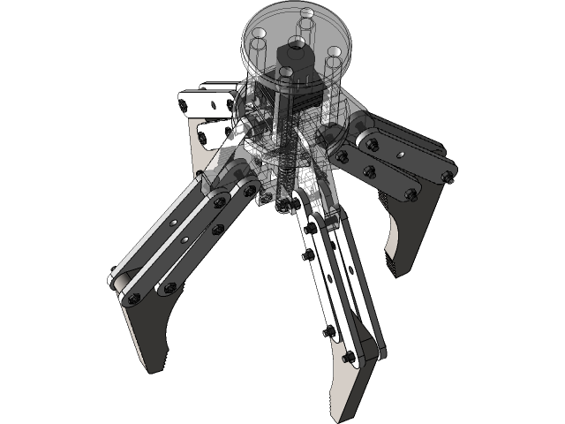

ROBOT CLAW:
Robot claws are one of the simplest types of grippers. They are popular among hobbyists, who are attracted to the simple design and functionality of these gripper types. Typically, robot claws (sometimes known as 'robot claw grabbers') consist of two claws (also known as 'jaws') that come together on opposite sides of an object to grasp it. In this article we will use the term “claw” in its widest sense, i.e., referring to any type of gripper that incorporates fingers or jaws that grasp items by closing around the outside of an object. These fingers can be hard or soft, with soft grippers finding many uses in food production and in handling delicate objects. UR robots support a variety of end-effectors, including claw-style grippers.

HOW ARE ROBOT CLAWS USED?
Roboticists have found numerous uses for robot claws based on this simple design. Robot claws are popular end effectors in manufacturing environments, where, for example, they can be used to perform applications for robots’ arms such as assembly, pick & place and packaging & palletizing. Robot claws can also be seen in space; NASA’s Insights mission uses a robot claw arm to place instruments on the Martian surface. Marine researchers have even used robot claws to conduct undersea research on jellyfish.

Designing Gripper Component:
Parts:
- Housing
- Finger
- Spider
- Nut
- Bolt
- Connecting Link
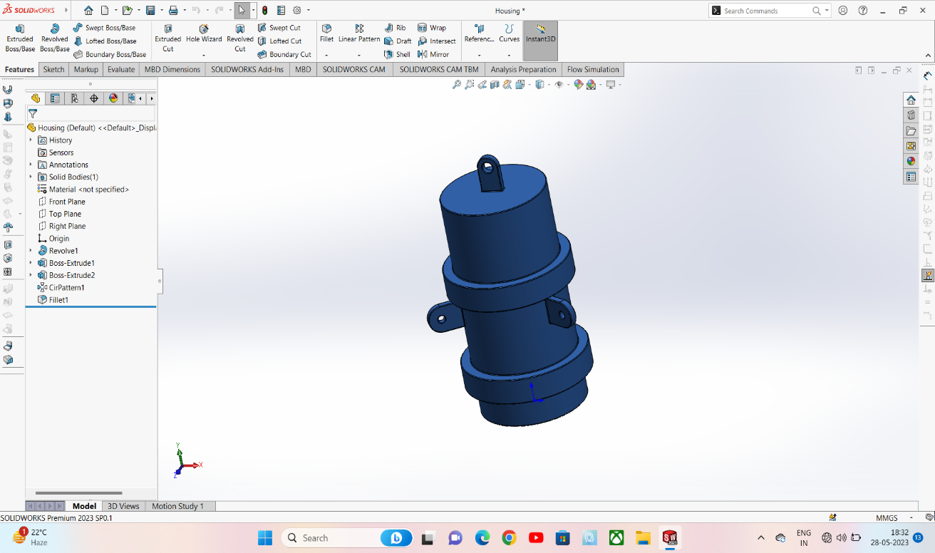
Housing-

- Sketch the housing design by using suitable dimensions.
- Use revolve command in order to get the desired shape.

Bolt:
- Sketch the head of the Bolt.
- Extrude Boss/Base the Polygon.
- Rounding the head.
- Create the shaft.
- Chamfer the end of the shaft.
- Make the thread of the bolt.
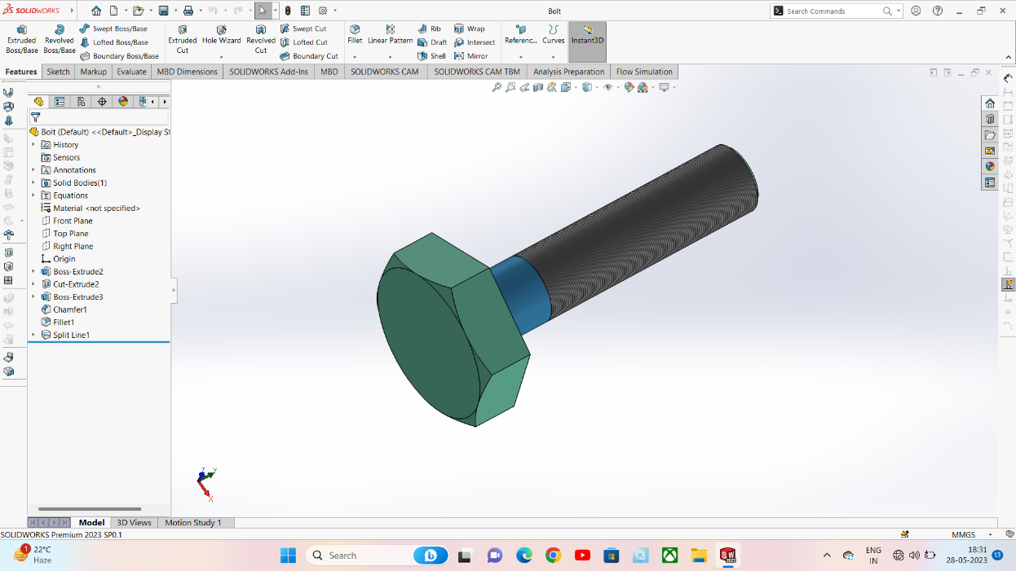
Nut:
- Selection of plane and basic sketch.
- Extruding the sketch.
- Adding chamfer.
- Creation of hex shape.
- Apply thread.
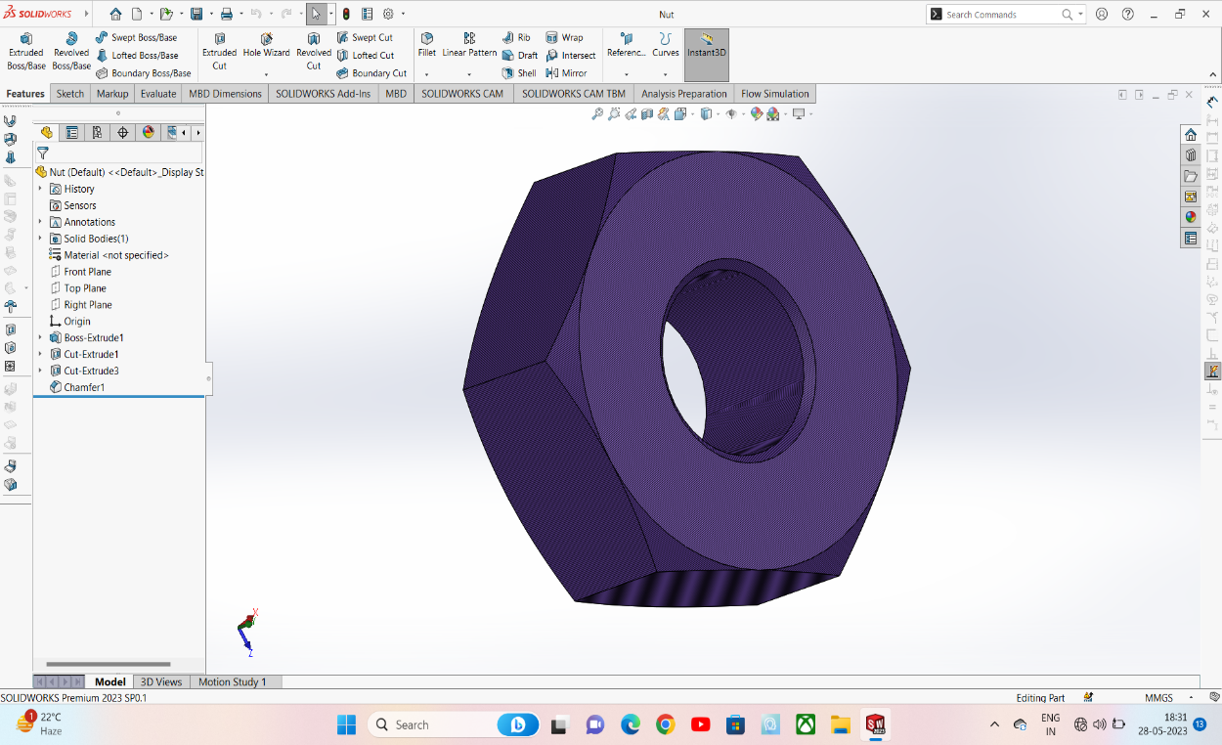
Connecting link
- Sketch the link design by using suitable dimensions.
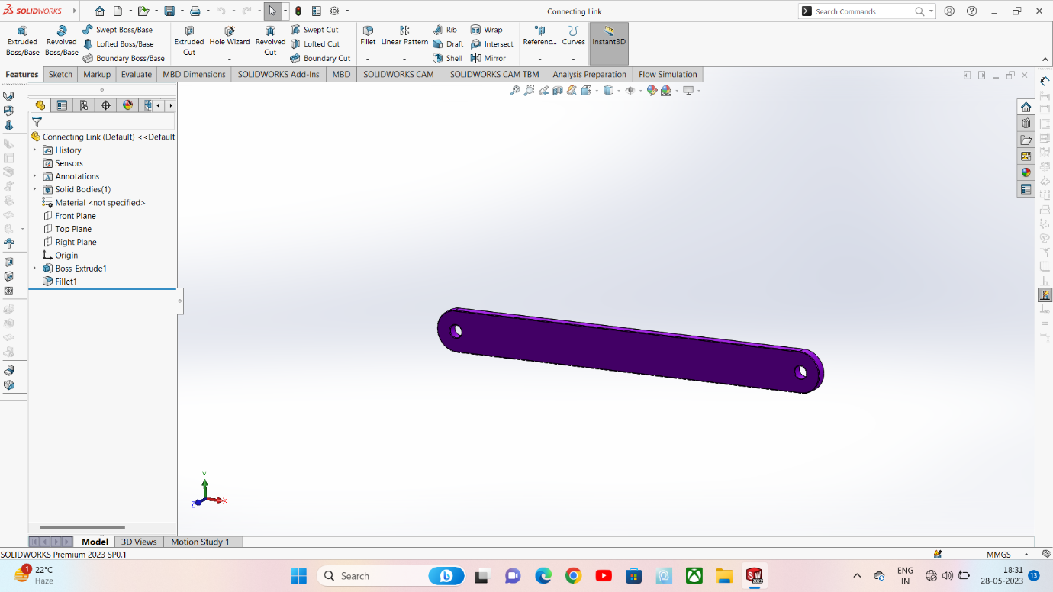
- Extrude the sketch in order to get desired shape.

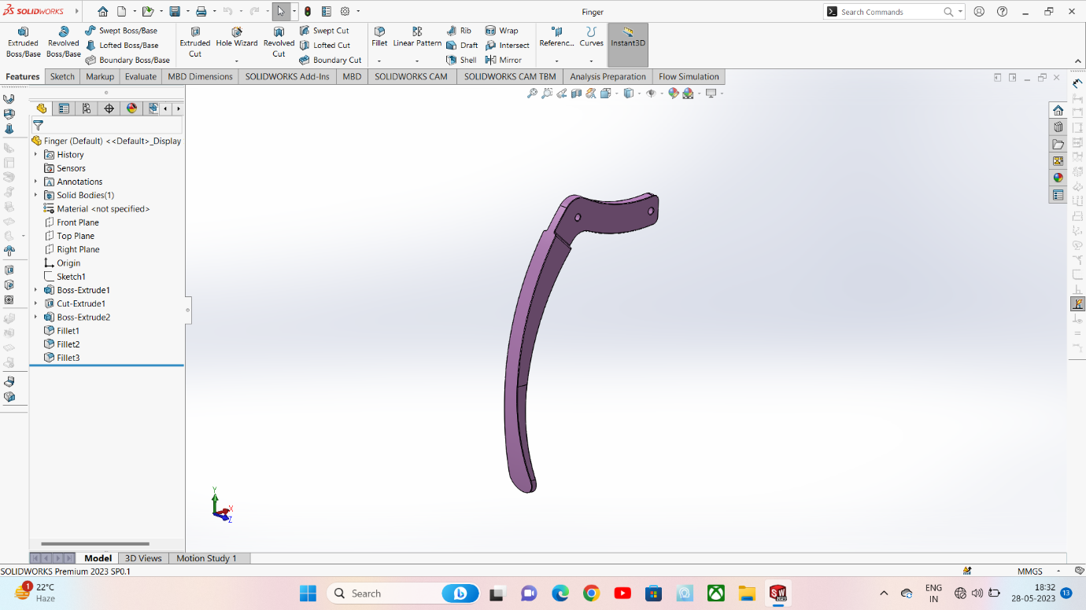
Spider:

Finger:
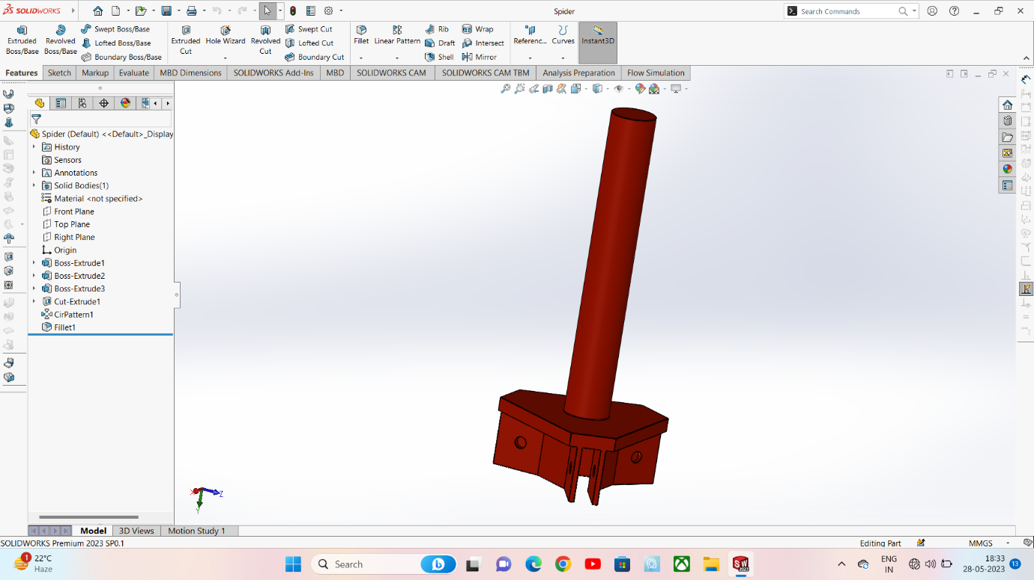

Final Model:
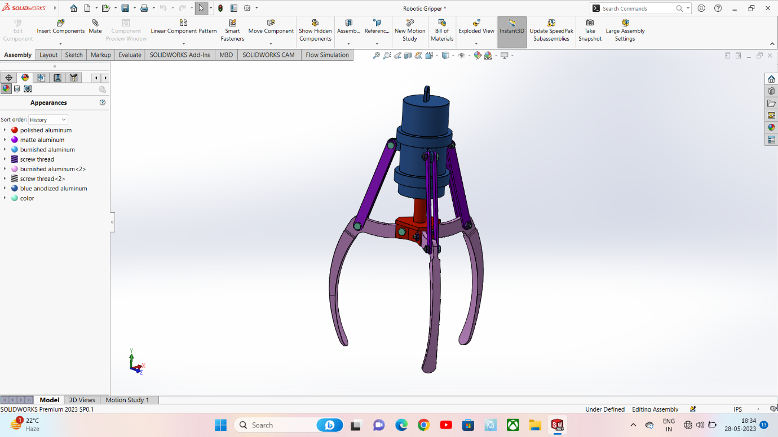

Application of robotic gripper:
1. Grippers for Assembly
For assembly tasks an electric gripper can be really useful. In fact, most assembly tasks are done at a single spot in the production line. This means the gripper that is positioned there must be flexible and be able to grasp different parts. There is absolutely no time for tool changing and this is why a flexible electric gripper should be used.
Also, grippers such as our 3-Finger Adaptive Gripper that have a programmable stroke can reduce the cycle time of the robot considerably. Especially since if you can set the stroke, the gripper doesn't need to run through its whole stroke before closing back on the object. The gripper can be set a little wider than the part and this can reduce the cycle time of the robot by reducing the gripper's motion.

2. Grippers for Machine Tending
The advantage of using an electric gripper in machine tending applications is that some grippers can handle a lot of different shapes. In fact, often the shape of the part will change from before and after the machining operation. This is why you should have a gripper that can grasp both the raw part and the finished part. Otherwise, you might be stuck using a tool changer and this can be complicated as well as time consuming.

Another aspect that is often overlooked is your environment. In machining operations, there could be a lot of fluids involved. Since this can affect the functionality of your robot gripper, you must choose a tool that can work well under your conditions. I regardless of the type of gripper you choose, the IP rating should be known to make sure your gripper can handle your working environment.

3. Grippers for Clean Rooms
Laboratories or metrology rooms might require clean air environments. By using pneumatic grippers, the air can be contaminated. Some grippers are specifically clean room rated and are designed to be installed in these kinds of rooms. A good alternative to the pneumatic gripper might be an electric on-off gripper. This kind of gripper has the same functionality without the disadvantage of air contamination.

References:
- https://blog.robotiq.com/bid/72815/Top-5-Applications-for-Robotic-Electric-Grippers
- https://en.wikipedia.org/wiki/Gripper
- https://en.wikipedia.org/wiki/Robot_end_effector

